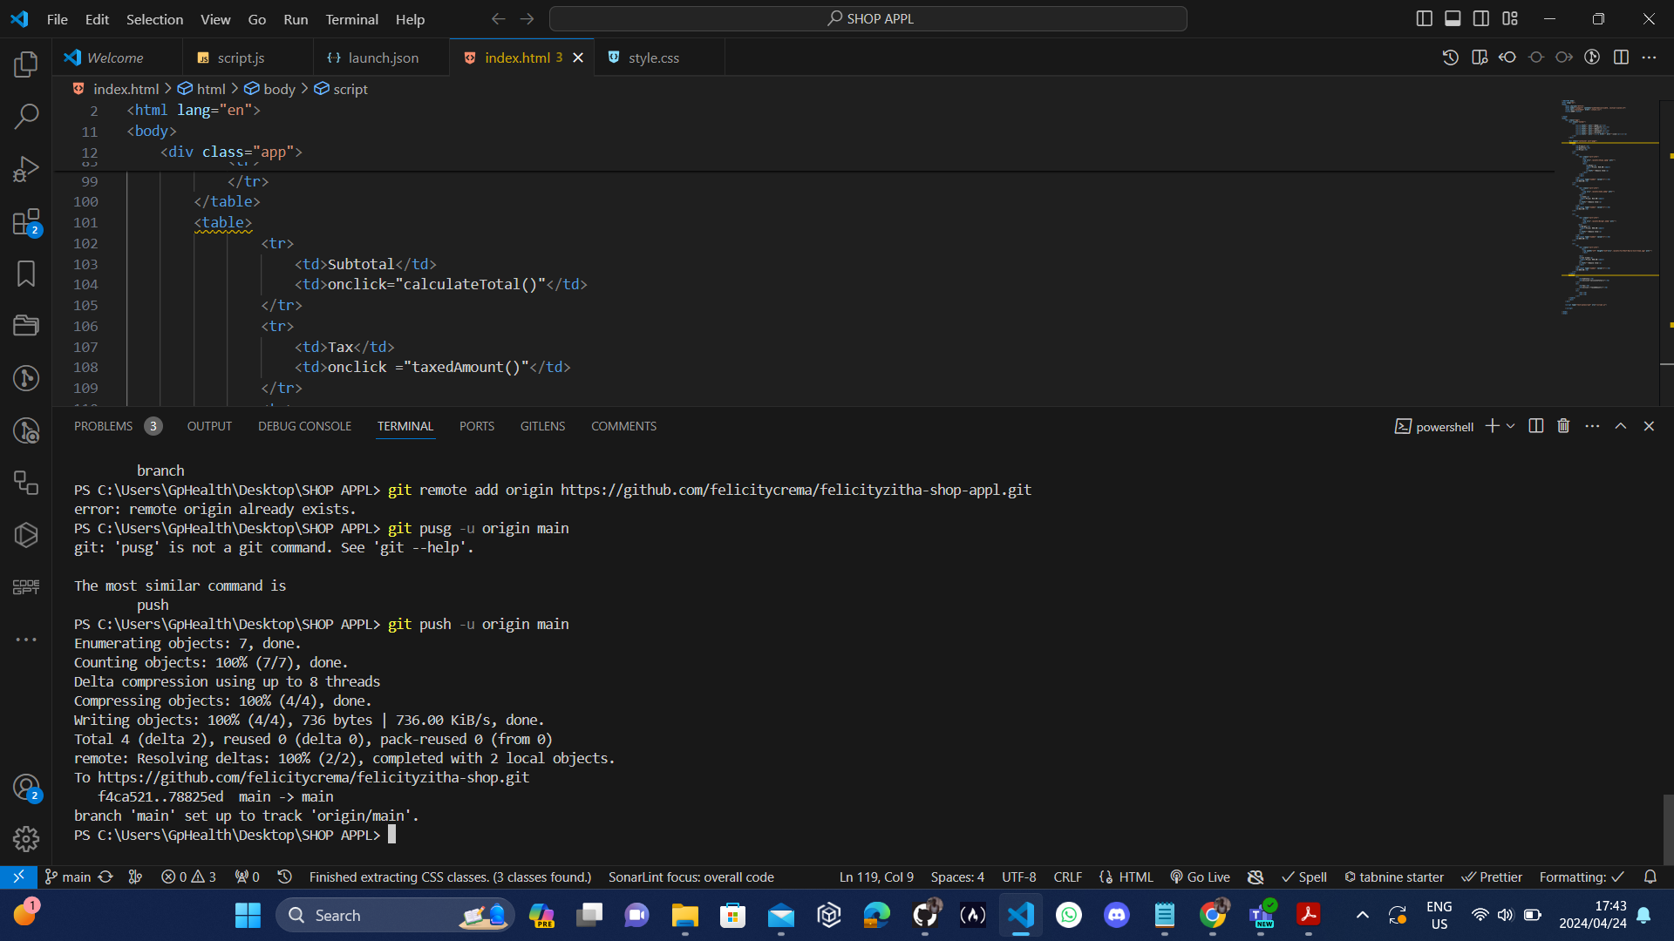

<https://felicityzitha-shop.netlify.app>

